3.2.3 Pirates are the Problem

What has 8 legs, 8 arms, and 8 eyes?

8 pirates.

Algorithmic Efficiency - define it in your own words

An estimate of how much computing power an algorithm requires. Efficiency is usually described in terms of how fast the algorithm can complete its tasks relative to the size of the data it's working with.

Steps 1 to 17 - show a screenshot of the data after you open it in google sheets.

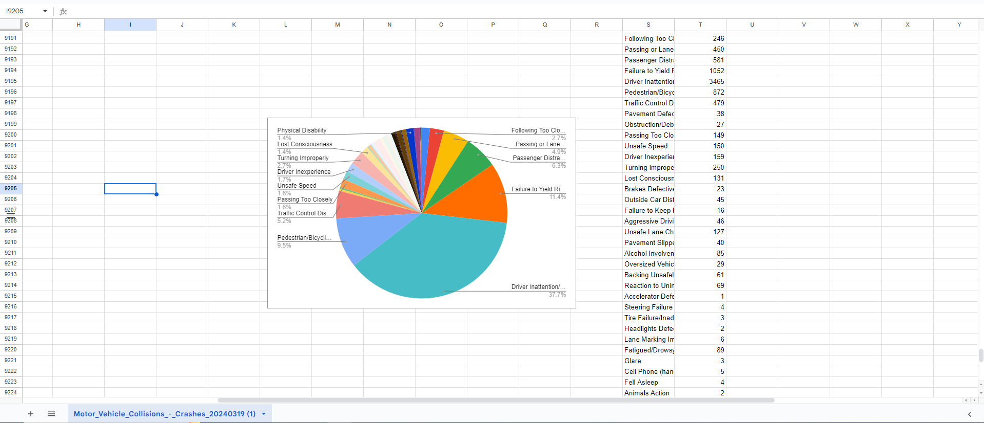

Step 18 - answer

Driver Inattention/Distraction

Step 20 - answer

53 times

Step 22 answer

1. 100 ms
2. 121 ms
3. 1,000,000 ms